BAWLF SCHOOL
Parent Student Handbook

Achieving Excellence

Revised August 2023

Table of Contents
Principal’s message 3
about bawlf schooL
MOTTO, MISSION, VISION, BELIEFS 4
PILLARS OF EXCELLENCE 5
BELL SCHEDULE 6
PROGRAMMING 7
HEALTHY SCHOOL COMMUNITY 8
LEARNING AND TEACHING
WELCOMING AND CARING 9
21ST CENTURY LEARNING PRACTICES 10
ASSESSMENT ………….………………………………….10
PowerSchool portal…………………………………....................................................................................................................10
PARENT-TEACHER CONFERENCES AND STUDENT-LED CONFERENCES 11
APPEAL PROCEDURE 11
INCLUSIVE EDUCATION 11
CELEBRATING EXCELLENCE 12
GETTING IN-TOUCH WITH BAWLF SCHOOL
PHONE AND EMAIL 14
CONTACTING STUDENTS 14
‘THE BULLETIN’ NEWSLETTER 14
SCHOOL WEBSITE 15
SCHOOL MESSENGER 15
WHO TO CONTACT IF THERE IS A PROBLEM 15
GETTING INVOLVED AS A VOLUNTEER
SCHOOL COUNCIL 16
BEST (BAWLF EDUCATIONAL SUPPORT TEAM) 16
HEALTHY LUNCH PROGRAM 16
GETTING INVOLVED AS A STUDENT
ATHLETICS 18
CONCESSION 18
STUDENT LEADERSHIP 18
YEARBOOK 19
AQUATIC PURSUITS 19
RANCH CAMP 19
SCHOOL POLICIES AND PRACTICES
CODE OF CONDUCT 20
STUDENT LATES AND ABSENCES 21
ACADEMIC INTEGRITY 22
APPROPRIATE DRESS 22
SMOKING, ALCOHOL AND DRUGS 23
LUNCHTIME ACTIVITIES 23
DRIVING AND PARKING 24
SCHOOL HEALTH AND SAFETY PROCEDURES 25
NUT FREE ENVIRONMENT 25
STUDENT MEDICATION 25
VISITING OUR SCHOOL 25
DOOR OPENING TIMES 25
EVACUATION DRILLS/ EMERGENCY EVACUATIONS 25
INCLEMENT WEATHER 26
STUDENT OWNED DEVICE PROTOCOL 27
MISSING EVIDENCE (ZERO) POLICY GUIDELINES 29
TRANSPORTATION OF STUDENTS 30
CLASS FAREWELL REQUIREMENTS 32

Welcome to a brand-new school year at Bawlf School.

We are wholeheartedly committed to "Achieving Excellence" in all aspects of education and beyond. Our school motto is more than just a phrase; it's a commitment, a promise to our students, their families, and our entire community.

The dedication of our remarkable staff to our students and all stakeholders is the cornerstone of our success. We are a family here at Bawlf School, united by a common goal: to provide the best possible educational experience for our students. Our educators go above and beyond to ensure that each child reaches their full potential, fostering an environment where learning is exciting, engaging, and meaningful.

We firmly believe that the key to a student's success lies in the partnership between school and home. It is in this collaboration that we truly thrive. Parents and guardians, your involvement is invaluable; you play an essential role in shaping the future of our students. Open lines of communication between school and home are vital, ensuring that we work together seamlessly to support our students on their journey to excellence.

Speaking of excellence, our school prides itself on achieving it in both academics and athletics. Our students consistently demonstrate high levels of academic achievement, thanks to the hard work of our educators and the determination of our learners. Additionally, our commitment to fostering a culture of excellence extends to our athletic programs, where our student-athletes shine as disciplined, dedicated, and respectful competitors.

As we embark on this new school year, I extend my deepest appreciation to our dedicated staff, students, parents, and the entire Bawlf School community. Together, we will continue to create an environment where every student is inspired to achieve their best.

We eagerly anticipate the opportunities, challenges, and achievements that await us in the coming year. If you have any questions, ideas, or simply want to connect, please do not hesitate to reach out. Let's make this year one filled with academic growth, athletic success, and the unwavering pursuit of excellence.

Ms. April L’Heureux
Principal

BAWLF SCHOOL PARENT STUDENT HANDBOOK Page | 4
School Motto
Achieving Excellence
Mission
To develop responsible and productive citizens through a balanced program which fosters the intellectual, social, emotional, creative and physical development of all students within a safe and caring environment.
Vision
- BAWLF students will be able to achieve their individual potential and create a positive future for themselves, their families, and their local and extended communities
- BAWLF students will have the opportunity to experience a variety of activities and programs to develop their skills, abilities, talents, and to accommodate their learning
styles
- BAWLF students will have high expectations set for them and receive constant and ongoing feedback
- BAWLF students and all staﬀ will be able to work in a safe and orderly environment where they feel comfortable, accepted, and respected
Beliefs
In Battle River School Division #31 and Bawlf School, we believe:
- Our fundamental purpose is to promote student learning, growth and understanding
  - When a student is in the greatest need, we will provide the greatest support
- All staﬀ need to be committed and dedicated to their own continuous learning
  - Passion and skill are central to being an influential and successful educator
- Everyone will be treated with dignity and respect in a safe and caring environment
  - Character education is an essential component of a child’s development
  - Optimal learning occurs when it is engaging, meaningful and active

Pillars of Excellence
At Bawlf School, we are committed to
Pillar | Description | Indicators
RESPECT | Create and build authentic caring and supportive relationships. | - Consideration and support for the esteem and needs of others  - Respectful communication with others  - Authentic relationships demonstrating honesty, openness, connectedness, kindness, humour and celebration
EFFORT | Demonstrating a strong desire to excel | - Engaged and committed to demonstrating your best  - Contribute to the success of the school community  - Purposeful collaboration toward a shared goal
ATTITUDE | Display a positive outlook that contributes to healthy, safe, and caring environments. | - Looking for the best in circumstances and relationships  - Recognizing that learning is difficult and growing comes through challenge  - Looking out for and caring for the school and the people in it
LEADERSHIP | Shared obligation to ensure and promote positive actions in the school and community | - On time and on task  - Integrity and honesty  - High expectations of self and others  - Upholding the values of the school and community  - Demonstrating respect by doing the right thing
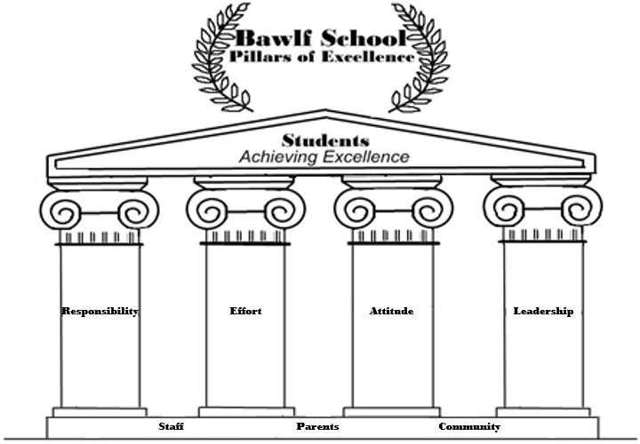

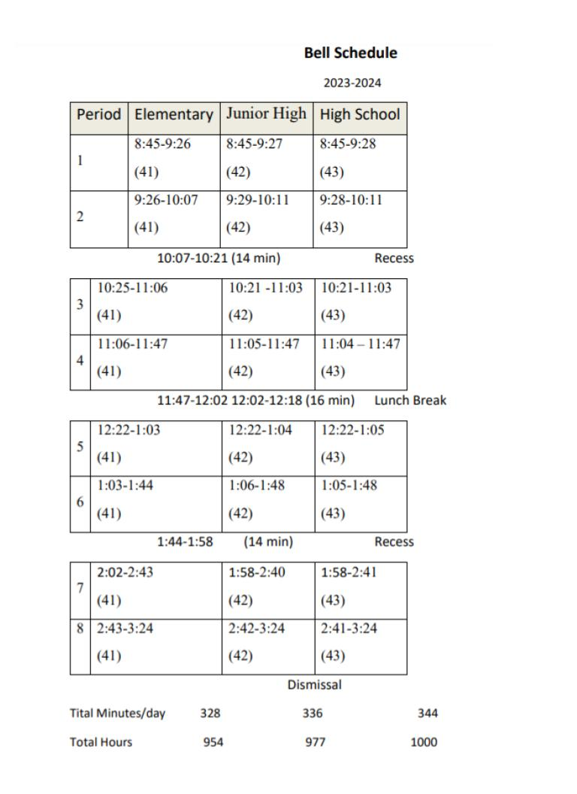

PROGRAMMING
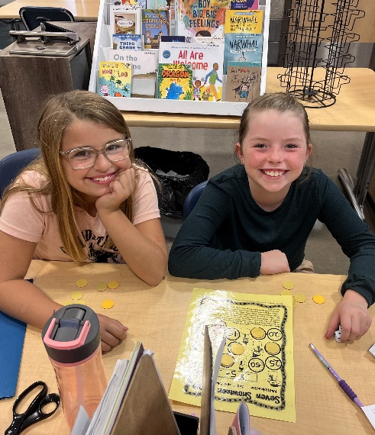
We take pride in the many aspects of our K – 12 program at Bawlf School. We have a very strong academic emphasis with our programming focused primarily on the core courses with opportunities to participate in a greater number of non-core subjects at the junior and senior high school level.
Grade 5 and 6 students are very excited to be able to develop their instrumental music skills in our Beginning Band program. Bawlf students in grades 4 - 6 acquire and maintain proficiency in a second language through French instruction. French is also offered at the junior high and high school level as an option.
Our junior high students participate in a wide variety of course offerings. In addition to core subject instruction, the junior high timetable contains Physical Education, Health, and Leadership, Art, STEM, Drama or Outdoor Ed as options. Students also travel to Camrose Composite High School one half day per week for Career and Technology Studies.
Although we are a small high school, Bawlf continues to offer a variety of programming choices including all diploma exam subjects. Our Art, Sports Performance, Foods, and Communications Technology programs are popular choices with students for non-core options.

HEALTHY SCHOOL COMMUNITY

Healthy children are better able to learn. At Bawlf School, we work purposefully towards establishing environments that support, ensure and integrate mental well-being, physical activity and healthy eating. We recognize it is important to encourage students to develop healthy habits now, so they can become healthy and successful adults. Eating well, being active and maintaining positive mental health can help keep kids healthy and prevent serious health conditions later in life.

PHYSICAL ACTIVITY

Students from grade K to 9 participate in daily physical activity. Students that are more physically active are healthier, do better in school, feel happier, and have more self-confidence. It is our hope that every student will develop the knowledge and skills necessary for a positive attitude toward physical activity—an attitude that will last a lifetime!

CONCESSION

Our concession offers healthy food options as well as tasty snacks. We also offer a vending machine that is stocked with healthy snacks and is made available to students at lunch time and
breaks.

Our fundamental purpose at Bawlf School is to promote student learning, growth and understanding in a safe and caring environment. We strive to support the academic, social, emotional and physical growth of all our students. It is our belief that when a student is in the greatest need, they are provided with the greatest support and treated with dignity and respect. It is through the development of caring relationships with students and staff, the character development that occurs through learning opportunities and our focus on achieving academic success that we see our students achieve success and grow into responsible members of society with a positive self-worth.

WELCOMING AND CARING

For most adults, it’s easy to think of schools as being welcoming and caring places. But for some, recollections of school days come with images of feeling left out, misunderstood or bullied.

In Bawlf School, we strive to ensure that all of our students feel welcome and cared for.

- Our “Pillars of Excellence” outline the ways in which we work toward ensuring a positive school experience for every child.
- We focus on character development throughout our day to day interactions as well as within specific programs such as Health and Wellness, Mental Health Capacity Building programs and Career and Life Management. Our students understand the importance of treating themselves and others with respect and dignity.
- We ensure that all students have at least one adult within our school family they know they can turn to for assistance. Meaningful relationships are fostered through our homeroom, our staff and our Family School Liaison Worker (FSLW).
- We work hard to provide continuous opportunities for our students to become involved in the school culture and develop their own personal sense of belonging. Our Student Leadership Team works hard to provide mentorship and create activities that are inclusive to all students.
- We teach the Dare to Care program to all students in kindergarten through grade 9. Dare to Care is a unique program regarded as Canada's most comprehensive and practical bully prevention program. Dare to Care enables schools, sports organizations, community groups, and workplaces to mobilize and maintain a caring community (.
- We are a school that promotes and role models a healthy lifestyle. Students are provided with daily physical activity, healthy lunches and a daily concession with fun, healthy food choices.

BAWLF SCHOOL PARENT STUDENT HANDBOOK Page | 9

21st CENTURY LEARNING PRACTICES

21st century learning and teaching allows us to envision and prepare for a future in which the classroom – and maybe even school – walls have come down; teaching is student-centered, flexible and inclusive of all; and technology abounds.
It is our goal to provide opportunities for our students to learn in innovative classrooms designed for the 21st Century Learner.
- We promote collaborative, transformational learning experiences that challenge our students to engage in and develop their higher level thinking skills and motivate them to take ownership for their learning and success.
- We provide outcome-aligned and inquiry-based learning opportunities. All students are engaged in authentic learning tasks which are relevant, practical and align to the Digital Age.
- We role model effective use of technology both within the classroom and in our day-to-day lives.
- We maintain a cell phone policy to promote student academics and mental health.

ASSESSMENT

Assessment is the process of collecting and interpreting information that can be used to inform our students and parents about the progress being made towards attaining the academic program goals. Assessment is ongoing and focuses on both the process and product of learning. It may include things such as conversations, observations, various products turned in for evaluation, peer evaluations, and self-reflections of learning. Regular assessment of work, either formal or informal, allows the teacher to provide both students and parents with ongoing feedback about each student’s learning.
Evaluation refers to a professional judgment on the overall achievement of the ‘learner outcomes’ within a course. It is made on the basis of the various assessment data collected and analyzed over a period of time. The learner outcomes are the key concepts that students are expected to know as they move through the curriculum in any course. Students will be evaluated based on these learner outcomes.
At the beginning of a course, all students will be provided with a course outline that clearly defines the evaluation standards for the course and provides them with a description of the learning outcomes being covered throughout the course.

POWERSCHOOL PORTAL

Both students and parents have access to their own personal up-to-date assessment information on our Bawlf School PowerSchool Portal. Using the link provided on our school website homepage, it is possible to access your child’s academic progress in any course as well as their attendance history. This information is password protected and each student will be able to access using their school username and password. Parents will receive an individual username and password at the beginning of the school year.

PARENT-TEACHER CONFERENCES AND STUDENT-LED CONFERENCES

We always welcome any opportunity to work collaboratively with parents to provide the best possible learning opportunities for our students. Parent-Teacher Conferences and Student-Led Conferences are a wonderful way to promote this collaboration and for our students to see and feel the communication and teamwork that exists between home and school. Bawlf School hosts Parent-Teacher Conferences in thefall for all grades and in the spring for grades 7-12 and Student-Led Conferences in the spring for grades K-6. We encourage our students to use these evenings to formally showcase their learning and achievements to their parents, while providing an opportunity for questions and inquiries between parents and teachers. Please refer to our school calendar for specific dates.

APPEAL PROCEDURE

Any student has the right to appeal a teacher-assigned mark for a course. If a final mark is in question the following action should be taken:
- Discuss the concerns regarding the final mark assigned with the classroom teacher who provided the evaluation.
- If you are still dissatisfied, appeal, in writing, to the school principal. This appeal should be made within one week of receiving the final mark and must include your reasons for the appeal.
A reply will be made in early February for semester one appeals and at the beginning of September for semester two appeals. The Principal’s ruling may be further appealed to the School Board if desired. For quartered classes, a reply will be made in the end of November, early February, and the end of April.

INCLUSIVE EDUCATION

In supporting all students, Inclusive Education provides the opportunity for students to reach their potential within their best learning environment at that time. It focuses on building student strengths in a safe, respectful and supportive environment within school and home communities. In some cases, students may receive specialized one-on-one instruction; in others, in-class accommodations and modifications may be more suitable.
Our Inclusive Education Community at Bawlf School includes, but is not limited to:
- ALL school staff (classroom teachers, educational assistants, Learning Facilitator, administration and support staff)
- Parents
- Alberta Health Services—Pediatrics (Speech-Language Pathology, Physical Therapy, Occupational Therapy, Respiratory Therapy, Audiology)
- Family-School Liaison Worker (for students ECS to grade 12 and their parents; the program offers support services and acts as a resource to families whose child may be experiencing difficulties at home or at school)
- Other outside agencies

CELEBRATIONS OF EXCELLENCE
The Bawlf School community is extremely proud of the accomplishments of our students. Although our celebrations of learning are not limited to a one-time event, we annually take the opportunity to publicly recognize their success.

ELEMENTARY
At the end of the year, Bawlf School celebrates our students’ hard work and accomplishments with a special assembly recognizing the achievements of all of our students in K-6.

Monthly elementary students participate in the monthly characteristic assembly. One student per homeroom is recognized for excellent demonstration of the monthly essential characteristic.

SECONDARY (Junior/Senior High)
Our Achievement Night celebrates the key message of “Excellence” that our school consistently promotes. Students are recognized not only for their academic excellence, but also Fine Arts, Green Certificate and RAP programs, leadership and citizenship. We hold our celebration in the fall of the following year to ensure requirements for the previous graduating class have been completed.

BAWLF SCHOOL JUNIOR HIGH AND SENIOR HIGH AWARDS AND SCHOLARSHIPS:
Junior High Academic Awards – Honours Achievement Award – students who have received Honors Standing (80% or higher) in a minimum of three of their core courses.
Citizenship Awards – student or students who display the following characteristics: participate in school/community service, citizenship in school/community, positive attitude, and strength of character to do the right thing.
Gr. 7-11 Bawlf School Awards Gr. 12 Village of Bawlf Scholarship
Leadership Award – Senior High Student Leadership Award - Awarded to the student who has continuously demonstrated outstanding leadership throughout High School, takes an active role in school activities, displays initiative and independence, consistently promotes Bawlf School’s motto of “Achieving Excellence”.
Volunteer Appreciation:
Concession Appreciation – in recognition of those students who make the commitment to volunteer to work on a weekly basis in the concession.
Staff Appreciation Award – in recognition of a student who is helpful around the school, is responsible, has a friendly demeanor, and a positive work ethic.

Fine Arts & Off Campus Awards:
Junior High Drama Award, Junior High Art Award, Junior High Outdoor Education Award, Junior High Leadership Award, Intermediate Band Award, High School Band Award
Emerging Artist Award – Given to a student in Art 10, 20, or 30 who displays exceptional skills and talent in the area of design and creativity. This student exhibits an appreciation for art and is willing to express their skills in a variety of projects.
Gladstone Ladies’ Club Green Certificate Scholarship – Awarded to the student who has demonstrated a high level of commitment to successful completion of the program.
High School Academic Awards:
Honour Roll (based on Alexander Rutherford Scholarship calculation) Top Overall in each grade
Top Student in each course in each grade.

Merit Awards: students who on a daily basis have a positive attitude, unrelenting work ethic, desire to achieve highest potential, commitment to improvement & growth
Gr. 7-11 Bawlf School Awards Gr. 12 Bawlf Lions Scholarship Grade 12 Scholarships and Awards
DALE ZARSKI ENGLISH 30-1 SCHOLARSHIP - Awarded to the Top Student in English 30-1
CAM LYSTER SOCIAL 30 AWARD - Available to a Social Studies 30 student who is engaged in class discussion and current events, recognizes the value of the content and the importance of civic engagement. The recipient thinks critically and is open to other perspectives which allows these attributes to reflect in their daily lives.
ATA BRSD LOCAL #32 ACADEMIC SCHOLARSHIP - Awarded to the student that excelled academically with the highest weighted average during their Grade 12 year.

ROSALIND ELKS SCHOLARSHIP
CAMROSE COUNTY SCHOLARSHIP - To receive this scholarship, the student must be a resident of Camrose County; be a hard-working, dedicated student who shows initiative and has had a positive impact in their school and/or community; be enrolled in a minimum of 60% of a full course load in a Post-Secondary Program of at least one semester in length, or an Apprenticeship Program.
GARRETT LANGILLE MEMORIAL AWARD - Awarded to the student who is willing to put others first; is an advocate for others, not just themselves; and has a positive outlook on life.
TY NASLUND MEMORIAL SCHOLARSHIP - Awarded to this scholarship is available to any Bawlf School student who has applied to a post-secondary program and is entering a diploma or degree Agricultural program, an apprenticeship or trade program or school.
GOVERNOR GENERAL AWARD - Awarded to the student with the highest average in Grade 11 and Grade 12 courses as listed on the student's official transcript issued by Alberta Education

The staff at Bawlf School recognizes the importance of communication between the school and the home. For students in grades K – 4, the major means of communication is the daily agenda. Teachers and/or students record daily and long-term assignments and tests here, as well as important notes for parents. Parents are encouraged to attach notes to teachers in the agenda. Grade 5, 6, Junior and Senior High students are encouraged to keep their own agenda. Grade 5 and up utilize email as the primary form of communication. Parents are encouraged to communicate with their child’s teacher early as this is the primary contact for school dealings.

PHONE AND EMAIL

There are several avenues parents may use to reach staff at the school. All teachers have an email address and invite you to correspond with them via email. Email addresses are communicated to parents on the course outlines handed out at the beginning of the school year. Please do not use email to communicate ‘last-minute’ directions. The office staff is available to communicate these messages and can be reached at (780)373-3784.

CONTACTING STUDENTS

In order to contact your child at school, please call the office and request that a message be relayed to the student. Except in emergency situations, students will be called to the office to receive the messages at recess, lunch break or the end of the day. If students need to be communicated around emergent situations, please let the office know and we will communicate immediately with the student.

‘THE BULLETIN’ NEWSLETTER

Lots of important information about what’s going on in Bawlf School is published in our newsletter, The Bulletin. The Bulletin is distributed directly to parents on a monthly basis via email and can also be found on our website bawlf.brsd.ab.ca. Please be sure we have your current email on file or contact us for alternate arrangements if you are without access so you don’t miss out on valuable communication regarding school happenings. Parents without access are asked to contact the office to make arrangements to receive a paper copy.
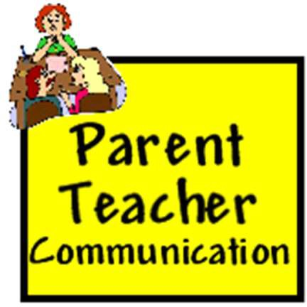

SCHOOL WEBSITE – bawlf.brsd.ab.ca

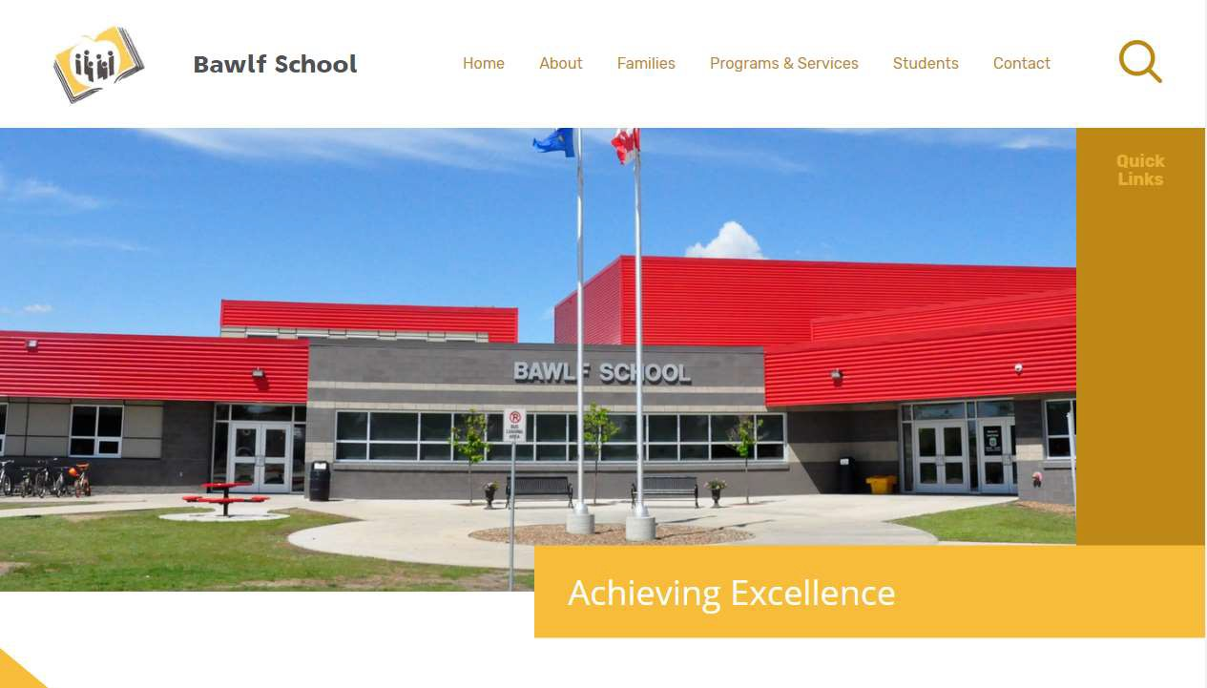
The Bawlf School website is a fantastic resource for all aspects of our school’s life, including virtually all of the supporting documentation that underlies the publication of this handbook. The site also contains current information on bus route cancellations, upcoming events and hosts the access link to the Rycor online payment platform and the Powerschool Student Information System.

SCHOOL MESSENGER

Our school utilizes the SchoolMessenger system to deliver text, email and phone messages, straight to your mobile phone, email, or home phone with important information about events, school closings, safety alerts and more. Parents and students can receive text messages or can use the School Messenger app. With the SchoolMessenger app, parents have 24/7/365 access to important school notifications such as bus cancellation, emergency alerts, etc. To sign up, please contact the office.

WHO TO CONTACT IF THERE IS A PROBLEM

It can sometimes be unclear for parents who they should contact given a particular question or concern. Parents are encouraged to communicate with their child’s teacher early as this is the primary contact for school dealings. If you require further clarification, please feel free to contact School Administration. If a concern or issue is of great significance, or the likelihood of a misunderstanding is great, a conversation over the telephone or face-to-face with the person is always best. Please feel free to book an appointment to have a meeting with the contact. Teachers and Administration are always willing to address questions, concerns or issues and appreciate open channels of communication. We recognize ongoing dialogue between the school and home is always in the best interest of the students.

BAWLF SCHOOL PARENT STUDENT HANDBOOK Page | 15

BAWLF SCHOOL COUNCIL

Welcome!
The Bawlf School Council would like to welcome you to Bawlf School and our portion of the handbook. Our council works throughout the year and is a means for parents and community members to work together with the school to support and enhance student learning. We are a collective association of parents, teachers, the administration and any staff and community members, and our purpose is to advise the principal and school board on matters relating to the school. We also play an active role in providing information to our parents and supporting our students and school. We believe that all members of the school community need to work together to provide the best possible environment for success for our students every day.

BEST is our fundraising group and our Healthy Lunch Committee works to provide hot healthy lunches in the school throughout the year. Both of these committees along with School Council provide additional opportunities for parent involvement in the school.

Our School Council believes strongly in the role of parents, teachers, and community working collaboratively in the school to support the success of our students.

Bawlf School Council Belief Statements
- Bawlf School is a collaborative partnership of students, parents, teachers, and community members committed to promoting the success of every student and celebrating the individuality of every learner.
- Quality education requires active involvement of the school community through consultation, collaboration and open communication between all members of that community including the school, the home and the community at large.
- Bawlf School Council in their advisory capacity can serve as an on-going mechanism for effective two-way communication and consultation between the school and the school community.
- Every voice has value and should be given opportunity to be heard through supportive processes of engagement and problem-solving.
- Relationships between the school, the home and the community can be strengthened through the Bawlf school council.
- By committing ourselves to these core beliefs, we are creating a community of learners united in helping themselves, others, and their community.

The School Council is supported by an executive including a chair, vice president and secretary. Other roles include hot lunch coordinator and non-officer parent representatives. We meet 5 times throughout the year to offer an opportunity to discuss programs, processes and events within our school community. We are always looking for volunteers and engaged parents to work with us, so please always know that you are welcomed and appreciated.

For more information, please contact:

Emily Herder
Chair, Bawlf School Council
bawlfschoolcouncil@gmail.com

ATHLETICS

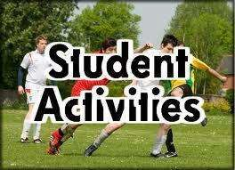
At Bawlf School we offer a wide range of extracurricular athletic activities students may have the opportunity to participate in. Grade 4-12 students are invited to participate in cross-country running. At the Grade 5/6 level, all students have equal opportunity to participate in both Minislammers (volleyball) and Minidunkers (basketball). At the Junior and Senior high level, our athletic teams have a strong history of being competitive and successful. We will be adhering to the Alberta Health guidelines and ASAA. Junior and Senior High
students may have the opportunity to participate in golf, cross country running, volleyball, basketball, badminton and track and field.
Minor officials are also an integral and valued part of our athletics program. Students not on a team are encouraged to become involved by helping out as a score-keeper, line judge etc.

CONCESSION

Students may be involved on a volunteer basis to work in the school concession, by making a commitment in September to be part of the concession’s operation on a one day a week basis for the entire school year. High school students can earn course credits for their hours of service.

STUDENT LEADERSHIP

Bawlf School is rich in its commitment to create ethical citizens in our entrepreneurial province. With that in mind, our High School Students’ Union is an active participant in engaging our school community in a variety of activities and monthly events, and thus creating leaders from our students. Theme days, charitable events, Christmas Luncheon, Pep Rallies, Random Acts of Kindness and Show N Shine are just a few of the experiences that the student body will be able to be involved with.

JUNIOR HIGH LEADERSHIP OPTION

Junior High students have an opportunity to join the leadership class as one of their option selections. During this class students volunteer in different parts of the school including tasks such as reading to elementary students, recycling, decorating bulletin boards, helping with PE classes, and much more.

YEARBOOK

Students have the opportunity to learn a variety of photography and desktop publishing skills as they work collaboratively to create the Bawlf School Yearbook. This extra-curricular activity also offers high school students the possibility of earning credits for the valuable contribution they make to our school.

AQUATIC PURSUITS

Students in grades 1 - 6 have opportunities to swim approximately three times throughout the school year. The location may also change, depending on the availability of the pool.

RANCH CAMP

Each year Bawlf School grade 5 and 6 students travel to Circle Square Ranch near Halkirk, right on the edge of a beautiful, prairie coulee in central Alberta. With 320 acres of land, they are able to offer a number of exciting activities to our students. Some of the activities offered are: horseback riding, swimming, archery, canoeing, mountain biking, and frisbee golf. This three-day, two-night outdoor education field trip is planned for the Wednesday, Thursday, and Friday following the long weekend in May. Typically the trip is partially funded by contributions from the school, student fundraising, and parental support.

CODE OF CONDUCT: BAWLF SCHOOL’S BEHAVIOUR MATRIX
At Bawlf School, we strive to develop students who are compassionate, creative, honest, inquisitive, passionate and reflective. Maintaining the dignity of each student in all situations is essential when managing behavior, providing meaningful learning opportunities and developing character. We ask our students to abide by the following, all-encompassing Behaviour Matrix:
 | Classroom/ Bandroom | Hallways and Common Areas | Gym | Washrooms | Entrances | Bus | Recess | Library
RESPECT  Create and Build Authentic, Caring, and Supportive Relationships | Let the teacher teach.  Be courteous. Raise your hand and be acknowledged before speaking. Treat and use technology appropriately.  Let your classmates learn. Celebrate others’ abilities.  Pay attention. | Walk quietly. Be quiet. Keep your hands to yourself.  Carry belongings safely.  Hold doors for others. | Treat and use equipment properly. Follow directions. Follow game rules.  Put equipment away properly. | Use inside voice.  Respect personal space. Don’t splash water | Use inside voice.  Respect others’ belongings  .  Clean or remove dirty footwear. | Listen to the bus driver. Be quiet.  Use kind words. Keep the bus clean. | Use kind words. Take turns. Share equipment. Following directions from supervisors. Put equipment away.  Put garbage in waste/recycle containers. | Listen to the librarian.  Be quiet. Care for your books.
EFFORT  Demonstrate a Strong Desire to Excel | Work the entire time.  Complete all work on time.  Come prepared for class.  Keep organized and neat.  Do your best. Hand in completed work. | Walk.  Keep hallways tidy.  Stay in your line.  Keep your hands to yourself. | Participate consistently. Try your best.  Set personal goals. | Wash your hands.  Conserve water and paper towels.  Use the garbage can. | Place footwear on racks.  Wipe your feet.  Keep boot room neat and organized. | Follow the safety rules.  Keep your belongings out of the aisle.  Be on time.  Wear appropriate clothing. | Agree on, and play by the rules. Enter and exit school quickly when bell rings.  Stay in the designated areas.  Wear appropriate clothing. | Return books on time and in good shape.  Pick a book quickly.  Put books back.
ATTITUDE  Display a Positive Outlook that Contributes to Healthy, Safe, and Caring Environments | Contribute to class. Be responsible for your own learning. Treat others fairly. Accept others.  Wear appropriate clothing.  Stay positive.  Do your best work. Learn from your mistakes. | Be considerate of the classroom learning.  Be considerate of others. Smile. | Play fairly.  Be a good sport.  Cooperate with others. | Return promptly to class. | Keep hands and feet to yourself.  Use good manners. | Care for the bus.  Consider the important role of the bus driver. Say thank- you. | Put garbage in the garbage can.  Use your hands and feet  respectfully. | Listen respectfully to stories.
LEADERSHIP  Shared Obligation to Ensure and Promote Positive Actions in the School and Community | Lead by example. Be a positive role model.  Encourage others. Make good decisions.  Help others when possible. | Model proper behaviour for others. Show new students around. | Include and encourage Others.  Display a positive attitude. | Consider the privacy of others. | Model positive behaviour. Hold doors for others. Greet guests and provide directions. | Encourage others to follow safety rules. Make good choices.  Model safety rules. | Model safe behaviour. Include everyone who wants to play.  Use outdoor equipment outside. | Model proper behaviour.

By committing to growth in the characteristics and behaviors listed above, our students prepare themselves to be the active, thoughtful and caring leaders of tomorrow and a climate of mutual respect emerges throughout our school.

Expectations are Just – “The teachers trust us…” Responsibility is Given – “We are treated like equals…” Problem Solving is Fostered – “We are listened to…”

Unreasonable expectations create points of contention between children and adults. Some rules are necessary. Others sterilize the learning environment and eliminate valuable problem solving experiences. We seize opportunities to increase the richness of experience both in and outside of the school and view each experience as an opportunity for some kind of authentic problem solving and learning opportunity to occur.

STUDENT LATES AND ABSENCES

Our attendance philosophy at Bawlf School is built on the belief that when students miss school they miss out. Regular attendance with minimal absences is a proven component of student success. There are many learning opportunities that occur every day within the classroom, which cannot be replicated with worksheets and homework when students are away. We recognize that some circumstances may prevent students from having perfect attendance and monitor this, not only because it is a legal requirement but because we want our students to have the best possible learning opportunities and chances for success at school.

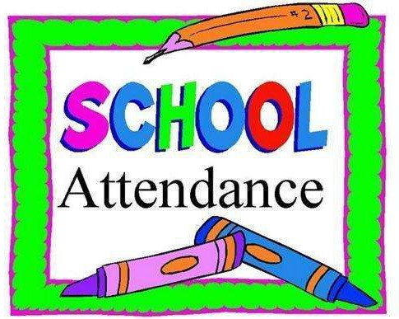
Please call the school office at (780)373-3784 or email both of our Administrative Assistants (eprice@brsd.ab.ca , bszott@brsd.ab.ca) to let us know if your child is going to be late or absent from school, ideally prior to the start of class. If not reported, the office staff will follow up with phone calls to the parent(s) to determine the whereabouts of your child.

Planned absences during the school day
When a student is planning on leaving the building in the middle of the school day they must sign out at the office in addition to letting their homeroom teacher know.
- Junior and senior high students can come to the office to sign out before they leave the building.
- Parents of elementary students are required to come to contact the office and inform one of our Administrative Assistants of your child’s absence.
This will help to ensure that all students are safe and accounted for throughout our building. Students who are absent from a class are expected to work with their classroom teacher to ensure that all missed assignments, quizzes, tests, etc. are completed within a reasonable, agreed upon time frame. In the case of an extended absence due to a family activity, we ask parents to contact the school well in advance of the absence to coordinate a plan for the classes and materials that will be missed.

Regular and punctual attendance is necessary for students to achieve success in school.
Absence from school does not excuse a student from handing in assignments or from completing them. Being late for class or school is a concern because of the disruption to the rest of the students. Therefore, regular and punctual attendance at school is critical for student success.

If we find that attendance is becoming a concern as we track attendance throughout the school year, further measures will be taken to offer assistance and support to ensure that your child is being provided with the best opportunities for success at school. Administration will work with parents to offer additional support if needed.

Non-class periods
As students enter into grades 11 and 12 they may begin to experience ‘non-class periods’ in their timetables. These are blocks of time that are set aside for students to pursue work experience or RAP programming opportunities outside of the school building or times where students have a non- instructional period due to programming choices.

- Students with non-instructional blocks are encouraged to use their time for study purposes and will be assigned to their cohort room for this work.
- Students leaving the building to fulfill alternative course obligations may do so in conjunction with their prepared timetable.
- Provided they are meeting their coursework responsibilities, Grade 12 students have the privilege of being outside the building during non-instructional time (i.e. arrive later in the morning if their first class does not begin at 9 a.m. or leave early if their course load concludes before the usual dismissal time). Students are reminded that this is a privilege and, consequently, may need to be revoked if abused.

ACADEMIC INTEGRITY

Academic honesty is a core value in our school. It is unacceptable for a student to commit plagiarism and/or cheating on any student work submitted for assessment. Academic dishonesty deprives everyone of quality evidence of student achievement and will be dealt with on a case-by-case basis.

APPROPRIATE DRESS

Although students are not required to wear a specific school uniform, they are required to adhere to certain basic guidelines according to dress.

Our guiding principles at Bawlf School are:
- Appropriateness and moderation.
- Concern for health and safety.

Students who are identified in violation of modesty and appropriateness will be provided an opportunity to change or be provided with appropriate alternative clothing.

SMOKING, ALCOHOL AND DRUGS

As per BRSD’s Administrative Procedure 165, “Division facilities and grounds are officially declared as zones free from the use, possession or offer for sale of tobacco, alcohol or drugs. Employees and students are also prohibited from attending work and/or school impaired from the use of alcohol or drugs.” Reporting to class or to a school activity under the influence of or in possession of alcohol or drugs is a very serious offence. The consequence will not be worth the risk, as these are considered serious violations of the behaviour code.

Under BRSD’s Administrative Procedure 355, the Division has a responsibility to ensure that each student and each staff member is provided with a welcoming, caring, respectful and safe learning environment. As such, the Division authorizes principals to conduct student searches where it is necessary and reasonable to do so in order for the principal to fulfill their obligations to maintain order and discipline in the school and on school grounds and during school activities. The Supreme Court of Canada has confirmed that a school authority may conduct a search of a student, without warrant, where there are reasonable grounds to believe that a school rule has been violated and evidence of the breach will be found on the student.
  - The Principal is responsible for maintaining an environment that is safe and conducive for learning.
  - The Principal and staff adopt a zero tolerance toward illicit drugs in the school. This includes vaping and vaping supplies.
  - The Principal stands in place of a parent, and therefore can access the entire school facility. That any evidence gathered as a result of a search could be used either by the school administration for discipline, or by the police for criminal charges.

LUNCHTIME ACTIVITIES

The lunchtime provides opportunities for students and teachers to eat lunch as well as have meetings or participate in other planned activities. Food and drink will be consumed in classrooms during this period of time. Please keep the lunch areas clean and pick up garbage.

High school students have the PRIVILEGE of leaving the grounds during lunchtime to go to the café, store, post office and bank. Habitual lates may result in the loss of this privilege.

Junior high and elementary students are not permitted to leave the school grounds during lunchtime unless they live in town. Special permission may be granted on a day-by-day basis with a note of parental approval. Leaving campus can be revoked at any time if unacceptable behaviour occurs.

Students may not;
- Congregate at a student’s home in or out of the Village at any time during the school day, regardless of the circumstances.
BAWLF SCHOOL PARENT STUDENT HANDBOOK Page | 23

- Operate or ride as a passenger in a vehicle during lunch for any purpose other than to leave school for work experience, RAP or an appointment with parental permission. Students who drive themselves to school are expected to leave their vehicle parked in the designated parking area until their school day is complete. Students are not permitted to sit in their vehicles during the school day, during breaks, or the lunch hour.

DRIVING AND PARKING

Many of our students choose to drive to school when they are able to do so. To assist us in making sure that the safety of all Bawlf students is being considered and monitored, the following guidelines must be strictly adhered to by all young drivers:
- Students must park in the designated parking area.
- Speed limits and road signs must be obeyed at all times.
- Stunting of any kind will not be tolerated.
- Once a student driver arrives at school, their vehicle must remain parked until they leave for the day. Drivers are not permitted to drive their vehicle during the lunch hour.
- Student drivers are not permitted to drive other students to and from school unless the proper paperwork and permission has been granted by administration.

BAWLF SCHOOL PARENT STUDENT HANDBOOK Page | 24

SCHOOL HEALTH AND SAFETY PROCEDURES

The Bawlf School Crisis Plan contains comprehensive procedures to maximize the safety and security of all students and staff in cases of emergency. Our practices include the following:

NUT-AWARE ENVIRONMENT

An anaphylactic reaction is an allergic reaction so severe that it is life threatening. While we cannot guarantee an allergen-free school environment, we recognize the dangers faced by students and staff with severe or anaphylactic reactions (allergies) to foods, and make every attempt possible to provide a safe environment for all. Parents and students are asked to double-check all food products brought into the building to ensure they do not contain nut or nut bi-products.

STUDENT MEDICATION

Parents are responsible for notifying the school of their child’s health needs and are asked to provide timely and accurate information about health concerns that could affect their child or students and staff at the school. Students may have medications administered while attending the school if appropriate forms are completed by the child’s physician (forms available at the school office).

VISITING OUR SCHOOL

For the safety of our students and staff, we request that all parents and visitors to the school, during the operational day, report to the office upon arrival. Parents or others who are dropping off items for students will generally be asked to leave the item at the office and the student will be called down at break time to retrieve it.
Visitors who are staying for a longer period of time will be asked to sign-in at the office.

DOOR OPENING TIMES

To accommodate the small number of early arrival students to the school each morning and ensure that formal supervision is in place for all students, the school doors are open at 8:25 a.m. Buses begin their arrival at approximately 8:25 a.m. and the first bell rings at 8:42 a.m. Under special circumstances or emergencies, please contact your child’s homeroom teacher to make arrangements for early drop off so we can ensure proper supervision is in place.

EVACUATION DRILLS

Bawlf School participates in a minimum of six evacuation drills each year so that all students and staff practice safe evacuation from the school. In addition, two lockdown drills and one off-site evacuation drill is conducted annually. Staff are well prepared to assist students in these drills and the school enlists the assistance of the Bawlf Fire Department and the RCMP in ensuring that our procedures are responsive.

EMERGENCY EVACUATION

In the case of an emergency, parents will be notified via phone. DO NOT phone the school or evacuation sites. Lines need to be kept clear for Emergency Services communications and for contacting parents. It is imperative that we have accurate contact information on file for your family. PLEASE ENSURE THAT ALL CONTACT INFORMATION IS PROVIDED TO THE OFFICE AND IS CURRENT.
If you’ve had recent changes, please relay these to the office. We also encourage parents to ensure their children have up-to-date parental contact information recorded in their agendas, cell phones, etc.

In the case of a need to send students home early in the school day, the following protocol will be followed:
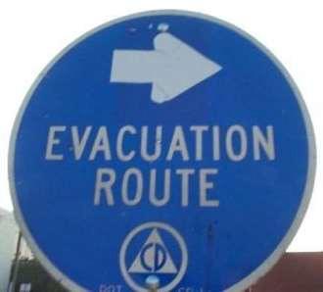
  - Junior and Senior High students who have cell phone access will be asked to contact their parents regarding the early departure. Families of those students who do not have cell phones will be contacted by a school staff member. Students in junior and senior high who have family members in younger grades will be asked to take responsibility for their siblings.
  - Parents of children in elementary school who have no older siblings will be contacted directly by school staff to ensure appropriate arrangements are in place.
Students will not be dismissed without confirmation that it is safe for students to go home.

INCLEMENT WEATHER

Reference: BRSD Admin Procedure #131 Cancellation of School Bus Route(s) due to Weather/Road Conditions

It is recognized that parents have the first decision as to whether or not to send their child to school on days when weather conditions are a factor. On occasion, it may be unwise to operate school bus routes due to the risks involved in transporting students as a result of weather/road conditions.
- Temperature
  - Bus routes will be cancelled when the air temperature reaches -40 degrees Celsius;
  - Bus routes will be cancelled when the air temperature combined with wind chill reaches -40 degrees Celsius.
- Fog
When considering whether or not a bus route should be cancelled due to fog, the driver shall make an effort to contact some parents at various locations on their route to determine the severity of the fog and whether it is widespread or localized. Drivers have the option to advise parents that they will try to run at a later time (e.g. 10:00 a.m.) since fog generally lifts as the sun rises. Once a morning route has been cancelled due to fog, and if conditions are not foggy for the afternoon route, drivers should make the afternoon run to deliver students home.
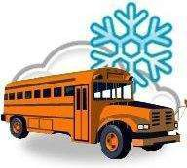
- Other Weather Issues
When a morning bus route has been cancelled due to any other weather related issue such as a winter storm or poor road conditions, drivers are not expected or required to run their afternoon route. Parents who have delivered their students to school are expected to pick them up at dismissal.

When a decision has been made between bus drivers and the school principal to
cancel all routes serving a particular school, the automatic phone fan out will be activated. Parents and students can also see route cancellations on the school website – bawlf.brsd.ab.ca.

STUDENT OWNED DEVICE PROTOCOL (May 2013)
At Bawlf School, we believe technology is a powerful tool which can be used to create authentic and engaging educational experiences for students. Our goal is to utilize technology to:
- Enhance the skills students need to live successfully in the 21st century
- Optimize the advantage of personal ownership of devices to learn, communicate and collaborate in school
- Increase student responsibility and appropriate use of technology.
As learners in the 21st Century, Bawlf School students are taught the skills and attitudes necessary to use technology effectively, creatively and wisely. We believe our students and staff possess and demonstrate the character disposition essential for the digital age; knowing not only how to use technology but when and why to use it with a sense of safety, community, fairness and responsibility.
As a result of collaborative conversations between students, staff and parents regarding proper and ethical use of technology in schools, the following Student Owned Device (SOD) Acceptable Use Agreement has been established for Bawlf School:

BAWLF SCHOOL SOD ACCEPTABLE USE AGREEMENT
- The ultimate responsibility for appropriate use of technology rests in the hands of the user.
- Staff and students will model digital citizenship and comply with all aspects of the BRSD Acceptable Use Agreement. This document is signed annually by all individuals in the Battle River School Division and covers the expectations for appropriate use of technology in schools.
- The primary use of Student Owned Device (SOD) technology in Bawlf School is for academic purposes. Teachers determine when and how technology is used in classrooms. Digital citizenship expectations and general classroom-specific technology guidelines will be communicated to students at the beginning of each course.
- Students who need to contact a parent or guardian for emergency purposes should do so using the office land-line so staff are aware of the circumstances and are able to provide assistance.

Electronic Device/ Cell Phone Policy 2023-2024 (September 2023)
At Bawlf School we make student academics as well as creating a safe and caring environment a priority. Cell phones and electronic devices often distract students from the purpose for which they come to school and can sometimes be a vehicle for bullying behavior. To support optimal student learning we wish to explain Bawlf School's electronic device and cell phone policy.

If a parent needs to get a hold of their child or leave them a message, please call our office at 780-373-3784.

Kindergarten to grade six students should not have any electronics at school. This includes during lunch and recess breaks. If students choose to have electronics for the bus ride to and from school, it is to stay in their backpacks while at school.

Grade 7-12 students:
- Students are encouraged to leave their devices in their lockers, however, if students take their cell phones/electronic devices to class they must be turned off. Students will place their cell phones in a hanging phone pocket (one phone per pocket) at the beginning of class and collect them at the end of class. Your child’s teachers will decide if students can use them during class for educational purposes.
- Please do not text/call your child while they are in class. If you need to contact your child during instructional time, please call our office.
- For privacy considerations, the taking of pictures, videos, or recordings at school without consent is strictly prohibited.

- Mobile phones/smartwatches should be ‘off and away’ during all class times in learning communities.

- Unauthorized use of electronic devices will result in the device being turned in to the teacher and returned to the student after class or at the end of the day.

- For repeated offenses, the device(s) will be given to the office who may return the device(s) to the student and/or contact the parents if the issue persists. Students may then be asked to turn their cell phone in the office each morning and pick it up at the end of the day or to leave it at home.

MISSING EVIDENCE (ZERO) POLICY GUIDELINES (May 2013)
The following guidelines provide teachers, students, and parents with information about student assessment specific to Bawlf School and in accordance with BRSD Administrative Procedure 360).
This information is supplemental and specific to Bawlf School.

COLLECTION OF EVIDENCE
At Bawlf School we do not take lightly the assigning of a zero for any student work. Students will be given ample opportunities to demonstrate their learning within the following parameters:
- Once students have adhered to the conditions set out by their teacher (e.g. completing corrections, reflection sheets, conversation with teacher, tutoring, etc.), students may be able to re-do summative assessments (excluding a final exam) at the teacher’s discretion. Teachers will determine deadlines for re-doing these assessments.
- After all scaffolding supports have been exhausted: students attending work sessions (at lunch time, during complementary courses, or after school), parents being contacted, and students being made aware of the full consequences of missing assessments, a mark of zero may be assigned at the teacher’s discretion.
- Criteria for deadlines and late acceptance of assignments will fall under a teacher’s professional judgment and will be clearly communicated to students.
- Decisions regarding academic dishonesty will be dealt with on a case by case basis, between students, teachers, parents and administration. In all cases (except for diploma exams or PATs), a reasonable attempt will be made to provide the student with an opportunity to correct their error in judgment.

TRANSPORTATION OF STUDENTS
Battle River School Division has several Administrative Procedures outlining safe practices for the transportation of students. The following excerpt from BRSD’s Q & A summarizes the inquiries we frequently receive regarding these Procedures. Information for BRSD transportation can be found here BRSD transportation:

Can a teacher/coach or parent volunteer transport students in their private mini-van or passenger vehicle to events such as sport games, etc.?
Yes, however, prior to transporting students, this person must contact their insurer to identify the additional risk and to determine if their insurer requires anything by way of additional coverage. Also, this individual must be registered to transport students via Administrative Procedure 559 – Transportation of Students in Private Vehicles (please contact Bev Szott, Administrative Assistant, for further information regarding this registration process).

A student is involved in a work experience assignment – can he/she drive him/herself in a privately owned vehicle?
The responsibility to transport to work experience programs is that of the student/parent. This is a condition of enrolment in the program at the time the student applies to participate. If they (the student and parents) do not agree to take on the responsibility for transportation, the student is not admitted to the program.

A team of students travel by school bus to another school for an after school sports activity. A parent comes to watch the game and provides a note to the coach that they will take their own child home.
If the parent is not approved as an authorized driver under Admin Procedure 559 – Transportation of Students in Private Vehicles – the parent can only take their own child away from the event. If the parent is approved under Admin Procedure 559, they may transport students who are not their own children, but only if written approval of the other child’s parent/guardian has been given to the supervising staff/coach prior to the commencement of the trip.
Only the “parent/guardian” can take their child away from an event,
not a “grandparent” or “sibling” unless prior written approval from the “parent/guardian” has been given to the supervising staff/coach. Staff/coaches have no discretion to deviate from this procedure.

A student arrives at the school on the bus, can they leave with another student in their private vehicle? Only if it is at the end of the school day for both students.

Transportation has been offered to get a student to a school related activity, but the parent and student decide that they will not make use of the transportation provided and will get the student to the activity in a private vehicle.
When the school provides transportation to an off-site activity, and a student wishes to transport themselves to the event, the student and his parent must sign a form (available from the student’s teacher/coach) stating:
- That the student was offered school bus transportation and that he/she declined it;
- That the parent/legal guardian accepts responsibility for the student’s transportation;
- That the parent/legal guardian does not or will not hold the school board liable for any accident or injury that may occur during the transportation to/from the off-site activity;
- That the student will not transport any other student;
- That the parent/legal guardian accepts that the school board’s Student Accident Insurance does not apply during the transportation portions of the trip, and the student is only covered from when he/she arrives at the school sponsored off-site activity until he/she leaves the off-site activity.
One Exception:
If two siblings are involved in the same activity and the parent wants the older sibling to transport the younger child, that parent must sign a form declining bus service for each child they are declining transportation for and confirming that the one sibling will transport the other one.

Can parents/students sign one form declining service for the whole year? Or is it event-specific? i.e., a student will drive himself/herself to basketball practices/games for the entire season of basketball… then he/she may also play volleyball, etc.
A blanket permission could be used for those parents requesting it, however, the teacher/coach in charge needs to have some kind of attendance in/out chart where he/she is aware of which parents have a blanket permission form signed. The insurer has suggested that the parent initial the blanket form each time they are taking their child home, or that the student initial each time they are transporting themselves. This doesn’t eliminate the paperwork completely, but it does allow for the school to continue doing their due diligence with respect to the responsibility and safety of the students.

Sometimes when coming back from an extra or co-curricular activity, the bus goes right by a student’s home. Can a student be dropped off on route rather than having to travel back to the school?
No. The travel to and from the destination is considered to be part of the extra or co-curricular event. Students cannot disembark from the bus at an alternate drop off location, (such as a highway stop along the route).

GRADUATION REQUIREMENTS

Bawlf School Class Farewell
Class Farewell is an important milestone in a student’s life. The Bawlf School class farewell committee hopes to make this a special time for all of the graduands and their guests. It is important that as a graduand, you keep informed and keep your parents informed as the year progresses. Please use this policy as a guideline and pay attention to announcements, the website and the farewell newsletters for updated information. Our goal at Bawlf School is to see every student receive a High School Diploma, Certificate of High School Achievement or Certificate of Completion. We believe that the following expectations will encourage and structure accountability and ultimately create success for our students.

Farewell Participation Requirements

During the Class Farewell Ceremony, students are presented their certificates in alphabetical order, and no distinction is made between the various programs offered at Bawlf School.

Students who hold positions on the Class Farwell Committee/Exercise program will be removed from their position if they engage in activities that are in violation of school policies.

Class Farewell and the School

The class farewell ceremony is a school-sponsored event meaning that students are responsible to the school for their decorum. Behavior that distracts from the dignity of the celebration may result in the graduand losing the privilege of continuing with the day’s activities.

Please Note: The Safe Grad or class barbeques are NOT school-sanctioned events. These events are left up to the graduands and parents to organize on their own without school involvement.

The following are the requirements to receive a High School Diploma in Alberta:
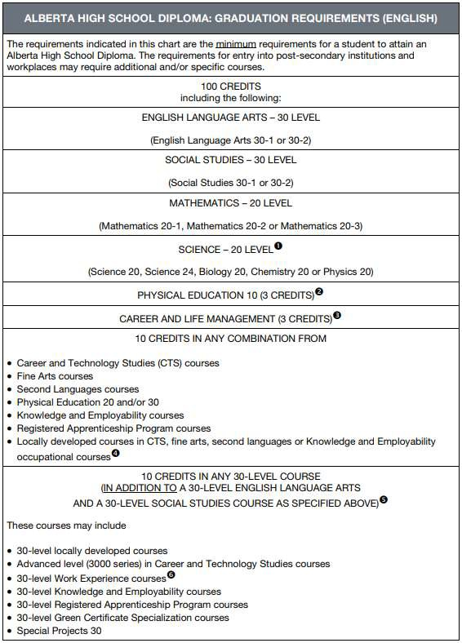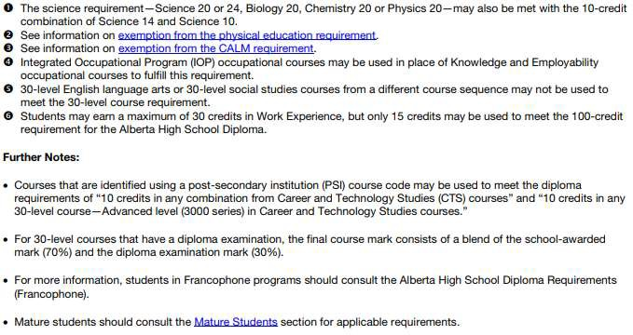

The following are the requirements to receive a Certificate of High School Achievement in Alberta:
